TALIWIND CSS

content: [

    "./src/**/*.{html,js}"

  ],

Meaning of above : public file ke under jitne bhi html and js ho unkeliye

1.Instalisation

Step 1 : install node js and add bin to environment .to know whether the node is installed or not run command in terminal : node -v

Step 2: then in the folder in which we want to create tailwind css file in which run command : npm init

Step 3 : then run command : npm I tailwindcss

Step 3.2 : run : npx tailwindcss init

Step 4 : create two floder : i)src ii)public and in src floder create a file name : style.css

Step 4.1:in tailwind config

/** *@type* {import('tailwindcss').Config} */

*module*.*exports* = {

  content: [

    "./public/*.html"

  ],

  theme: {

    extend: {},

  },

  plugins: [],

}

Step 5 : in package.json file in script : after removing test eg {*"test"*: "echo \"Error: no test specified\" && exit 1"

}

Add :

*"build"*:"npx tailwindcss -i src/Style.css -o public/output.css"

Step 6 : in terminal run : npm run build

Whole package.json file :

{

*"name"*: "course",

*"version"*: "1.0.0",

*"description"*: "My first Tailwind Css course",

*"main"*: "index.js",

*"scripts"*: {

*"build"*:"tailwindcss -i src/Style.css -o public/output.css"

  },

*"author"*: "Ajaj",

*"license"*: "ISC",

*"dependencies"*: {

*"tailwindcss"*: "^3.1.6"

  }

}

Note : when ever I change the style.css of src I need to run command : npm run build

ii)to solve the above problem of again n again running of command : npm run build it need to make a little bit modification in build element that I created in package.json :

*"build"*:"tailwindcss -i src/Style.css -o public/output.css --watch"

Instead of --watch i can use -w

Step 7 : to include tailwind utlity class I just need to add the flowing in style.css and run command in terminal : npm run build

@tailwind base;

@tailwind components;

@tailwind utilities;

Manul adding tailwind :

<!DOCTYPE html>

<html lang="en">

<head>

    <meta charset="UTF-8">

    <meta http-equiv="X-UA-Compatible" content="IE=edge">

    <meta name="viewport" content="width=device-width, initial-scale=1.0">

    <title>Tailwind Css</title>

    <link rel="stylesheet" href="./output.css">

</head>

<body>

    <p class="font-sans text-lg">Lorem ipsum dolor sit, amet consectetur adipisicing elit. Est neque libero inventore qui nihil quasi quo doloremque? Ipsa nemo saepe recusandae facere, dolore vel est ratione, incidunt ab totam fuga.</p>

</body>

</html>

🡺 I can also use cnd to add tailwind CSS like :

Link :

<script src="https://cdn.tailwindcss.com"></script>

Disadvantages of using cdn :

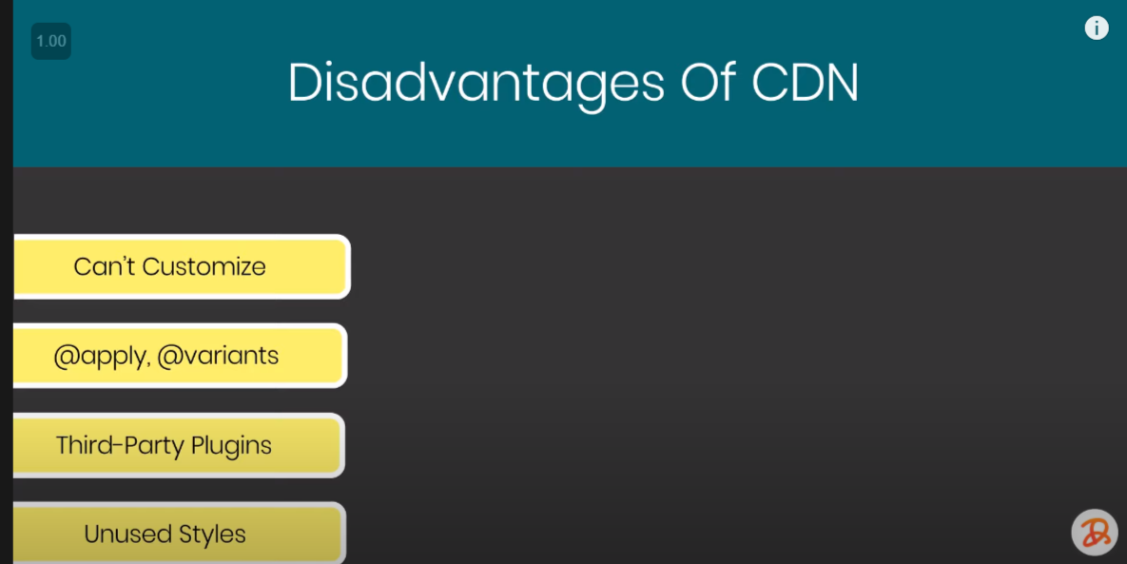

Can not apply : @apply , @variants

Can not use third-party plugins

Cant remove : unsed styles

Tailwind css now upgrade : we can now customize , can use @apply , @variants , third party plugins

1. FONTS :

A) font family :

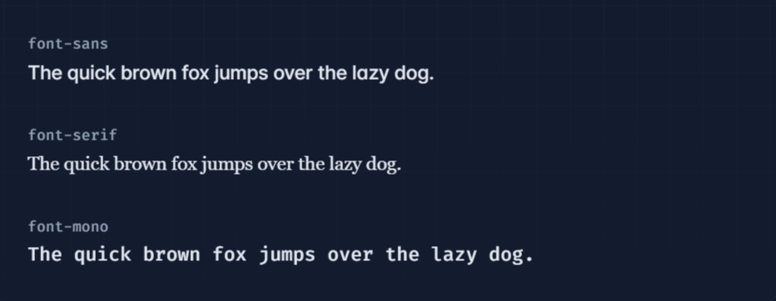

B)font size

<https://tailwindcss.com/docs/font-size>

**C) font smoothing :**

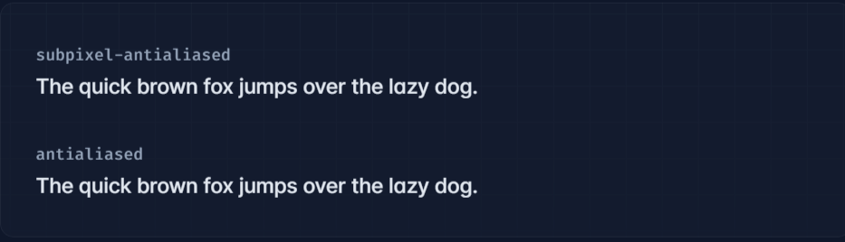

**D)font-style :**



**E) font-wight :**

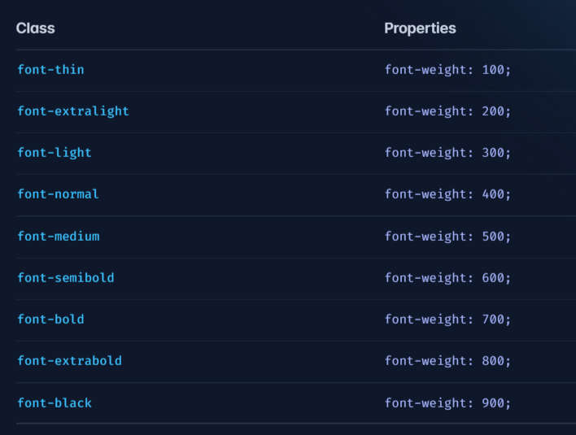

**vi)letter-spaccing :**

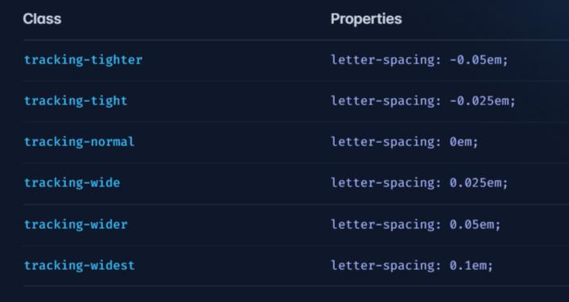

**vii) line height :**

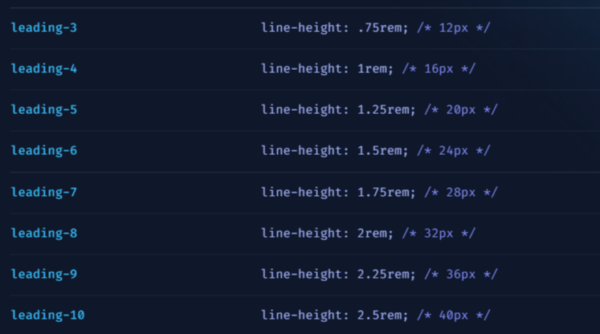

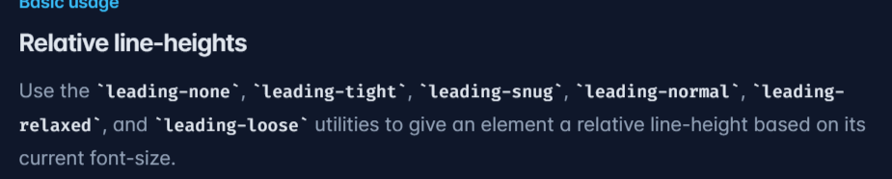



**2. list :**

**i)list-style :**

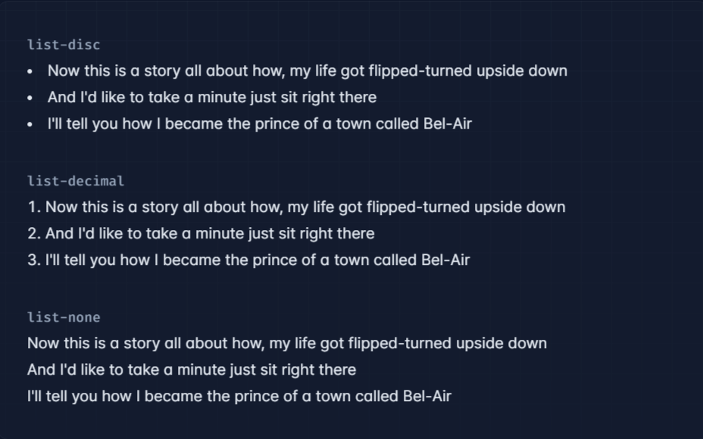

**ii)list-postion :**

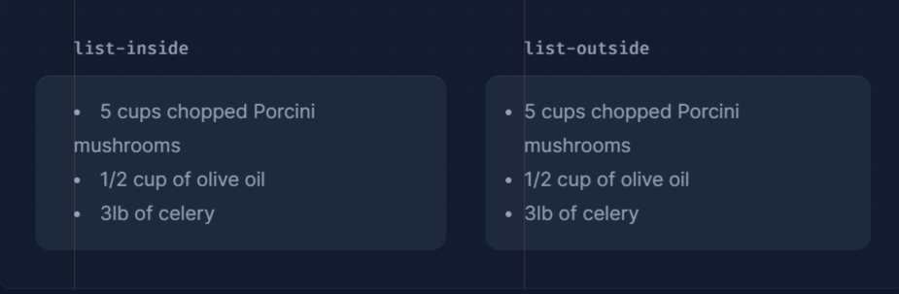

**3.Text**

**i)Text-align :**

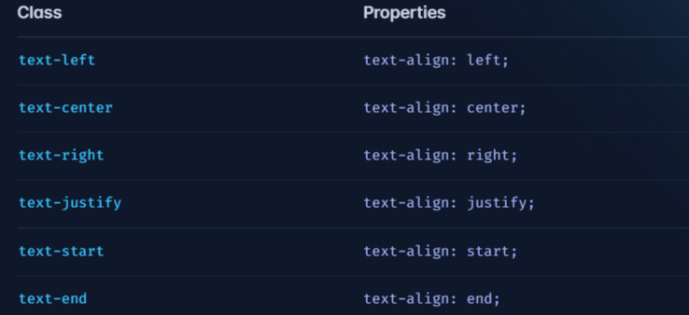

**ii)Text -color :**

**eg : text-sky-500**

**iii)Text-decoration :**

**A)**

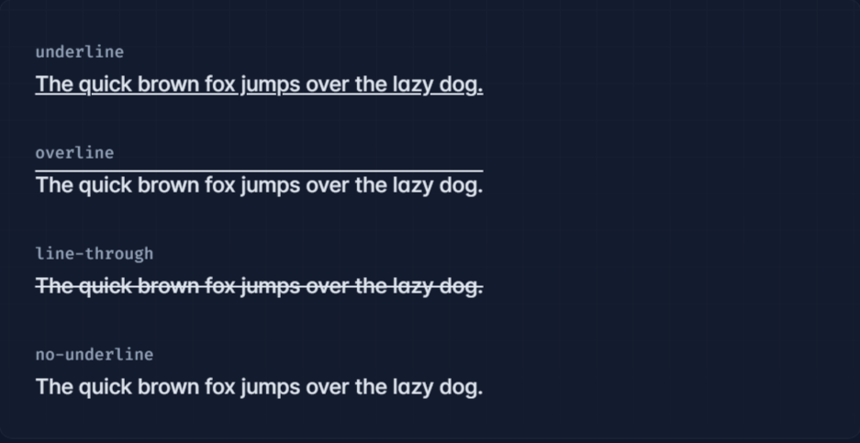

**B)text-decoration color :**

**eg : decoration-sky-500**

**C) text-decoration-style :**

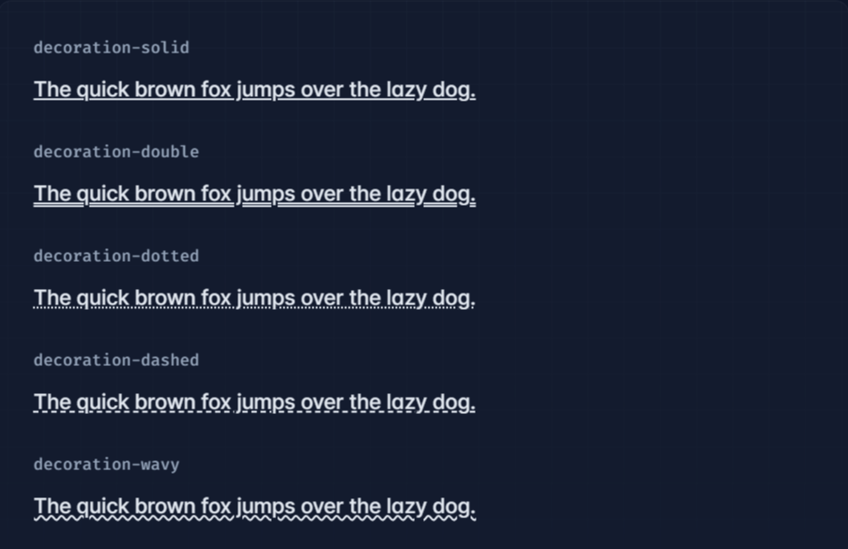

**D)tex-deoration-thickness :**

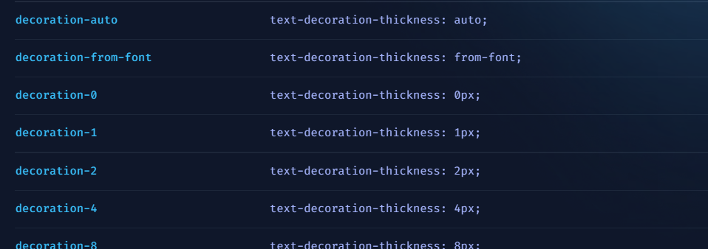

**E)underline-offset :**

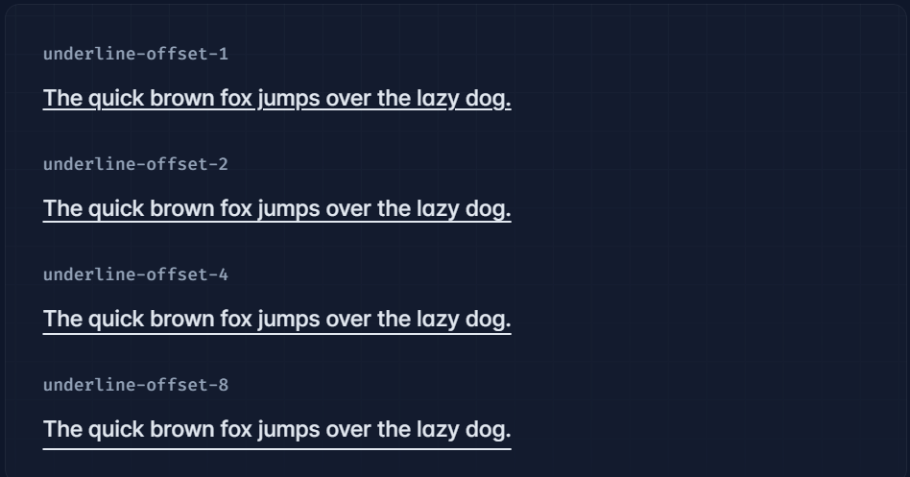

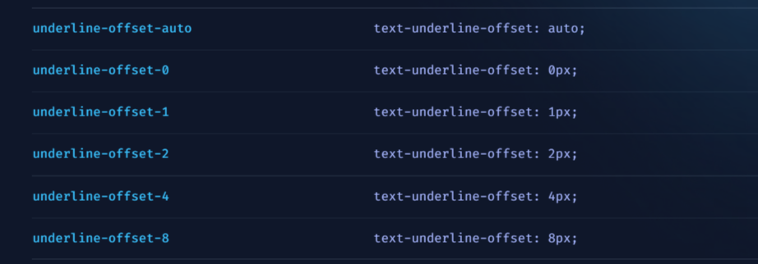

iv)Text-transform :

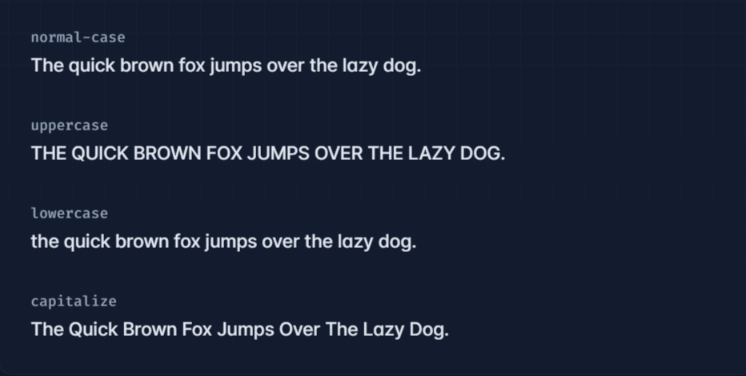



V)text-overflow :

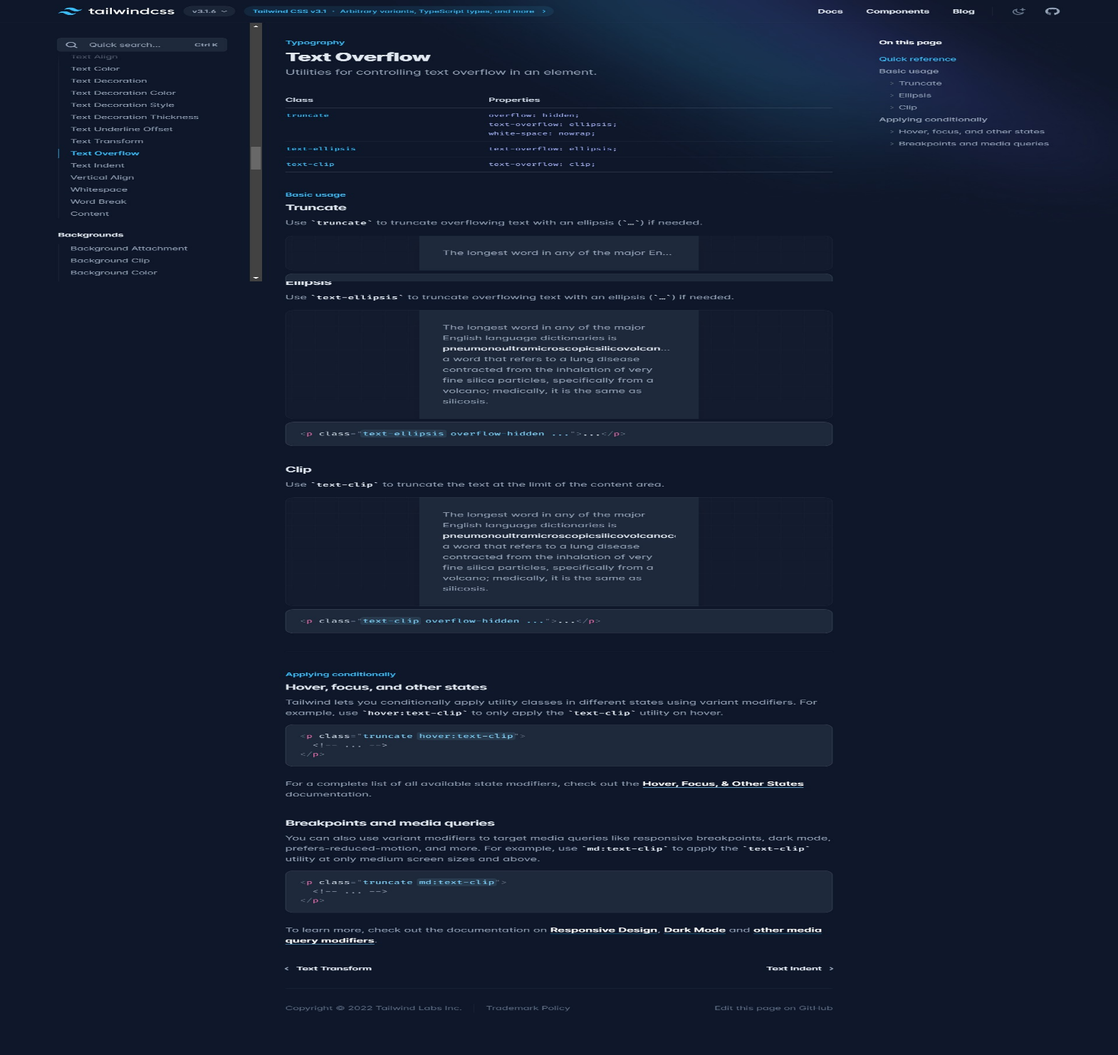

vi)text-indent:

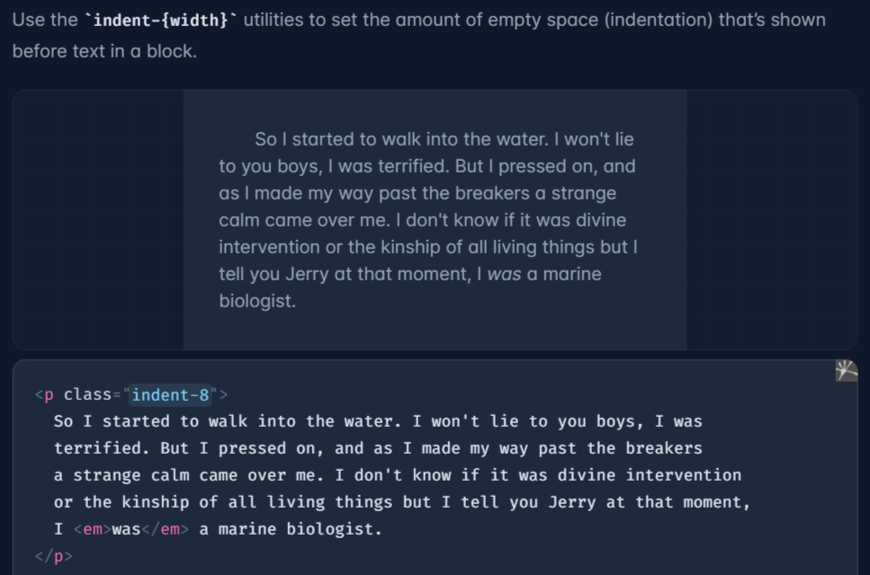



Vii)vertical align :

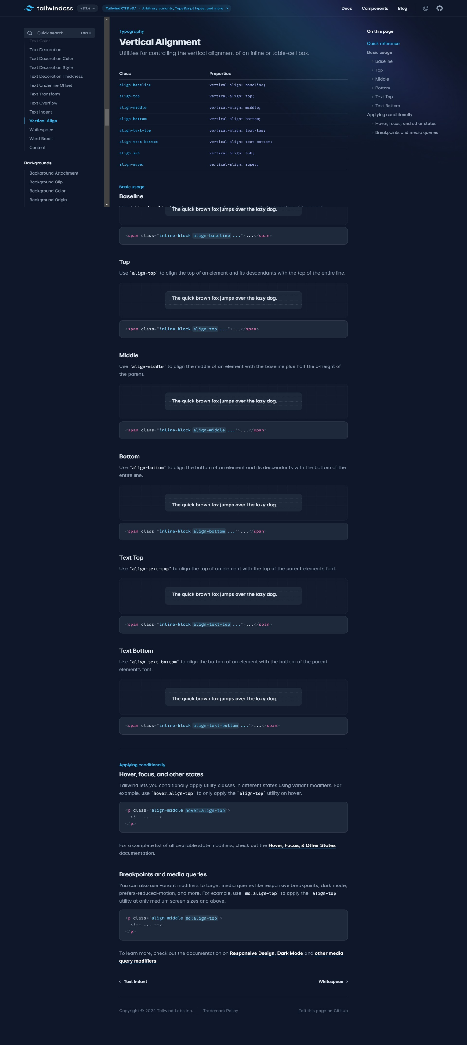

4.Spaccing

i)padding :

<https://tailwindcss.com/docs/padding>

ii) margin

<https://tailwindcss.com/docs/margin>

we have margin-auto as well

iii)space :

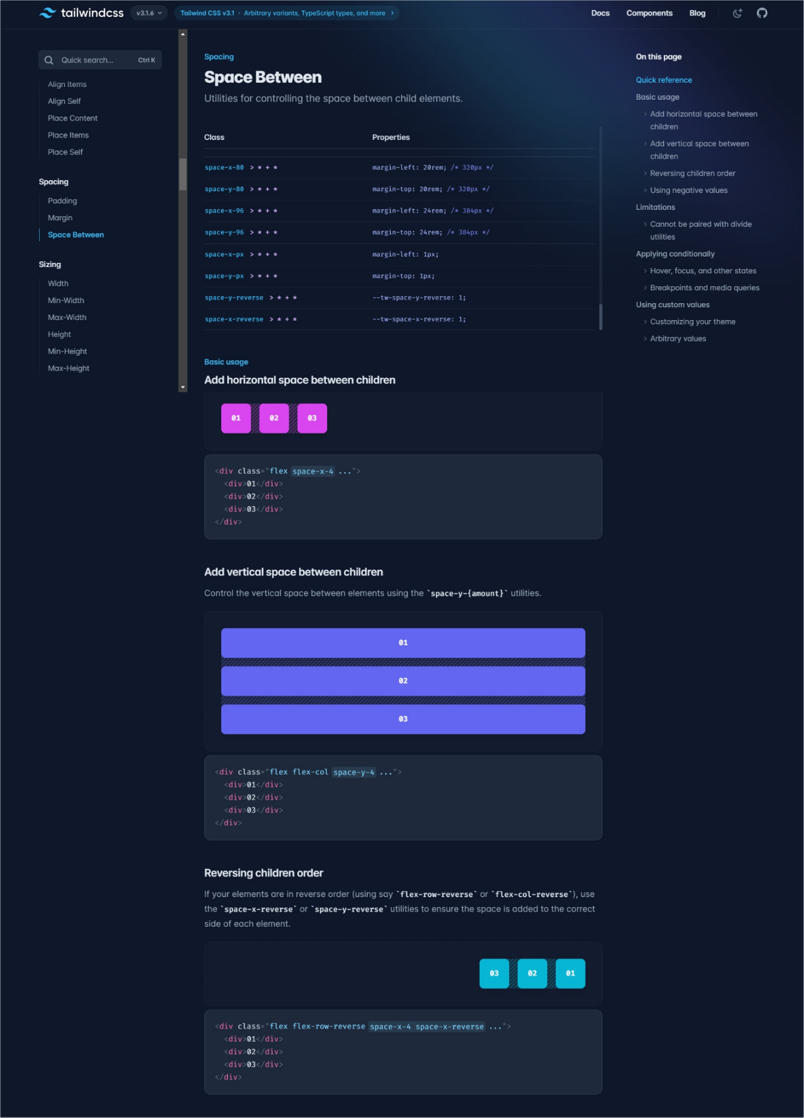

5.Sizing

i)width :

<https://tailwindcss.com/docs/width>

ii)height

<https://tailwindcss.com/docs/height>

iii)min-width

<https://tailwindcss.com/docs/min-width>

iv)max-width

6.Background

i)background-color :

bg-color-500

iii)background-image : to put background image we have to put it manually by using style attributes .

ii)background-attachment :

<https://tailwindcss.com/docs/background-attachment>

7.border

8.🡺Container :

<https://tailwindcss.com/docs/container>

9.flex :

<https://tailwindcss.com/docs/flex-basis>

10.grid

11. utlity first Api :

Throught this : if I have to use same ultity class on more element then I can save my time by writing utlity first Api .

Eg : here we are applying same class on two give button I can save my time by using utlity first Api

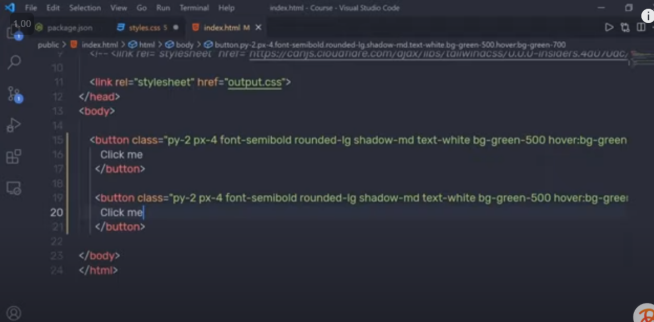

Better way :

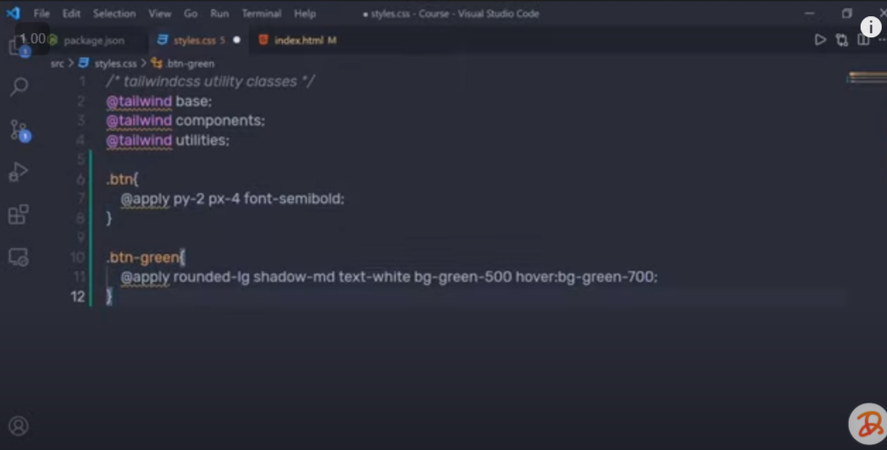

12. pseudo selector :

<https://www.youtube.com/watch?v=lZp4salRFFc&t=2549s>

i)hover

ii)

a)focus

B) focus-within

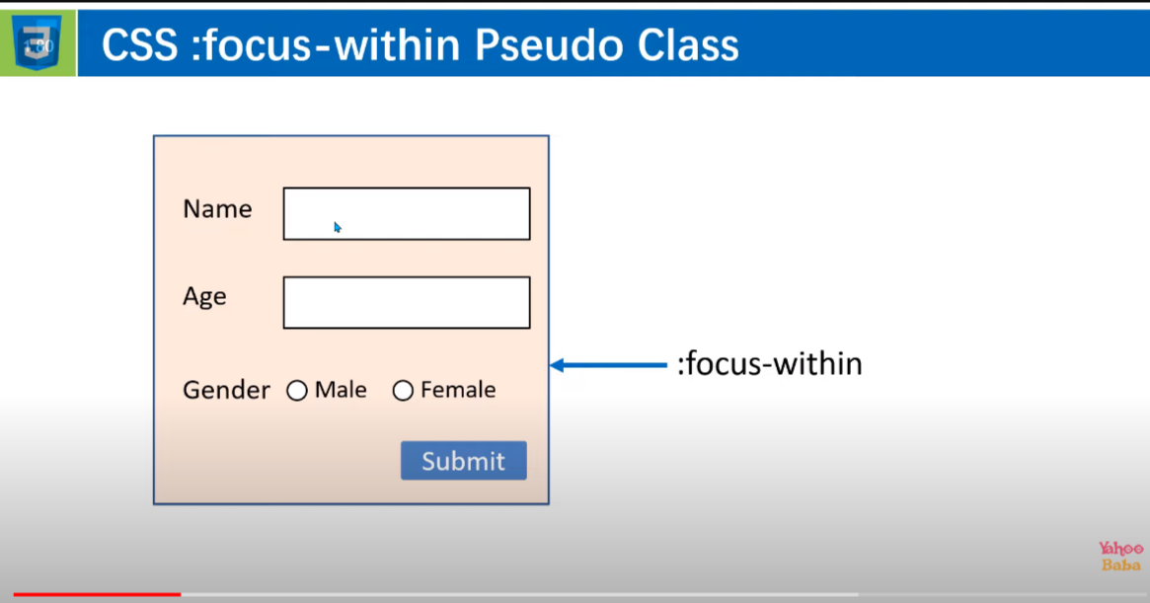

Link :

<https://www.youtube.com/watch?v=hoYadtwOpnQ>

C)focus visible :

it is use to to give focus effect when some focus some thing from the keyboard\

iii)active

difference between active and focus :

active : it is temporary

focus : it is permanent until the focus is not removing

iv) visited

v) target

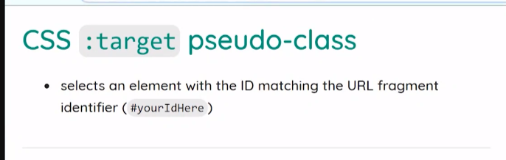

Syntax :

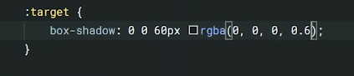

Note :above will going to put the same property to all the url fragment but we can also give different property to different url froagment

Eg :

#box:target{

}

vi)

A)first ~=first-child

B) last~=last-child

C)odd~=nth-child(odd)

D)even~=nth-child(even)

vii)

A) :required

note : this will going to apply on the field that has required attributes

eg :

<input type="text" required>

Note : just like target we can give same property for every required and we can also use with the target selector

Eg :

1. :required -> for all
2. [input=”file”]:required this is for input file onl

B) :disabled

C) :valid and :invalid will automatically going to apply based on the input type and user value .

d):placeholder

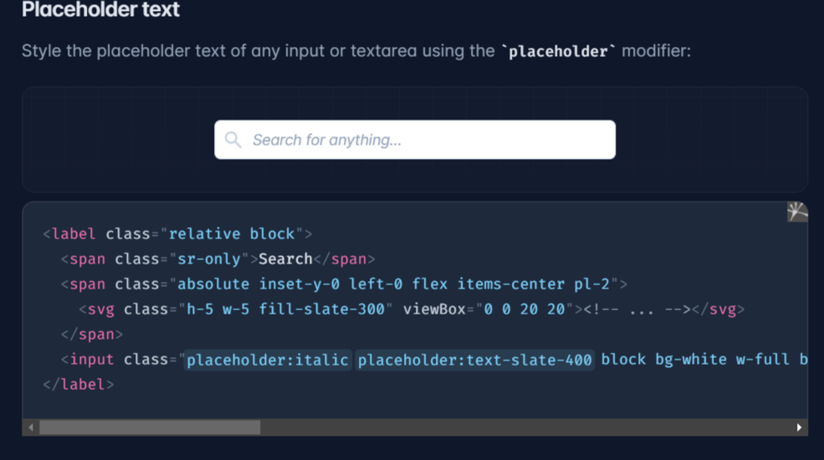

viii)

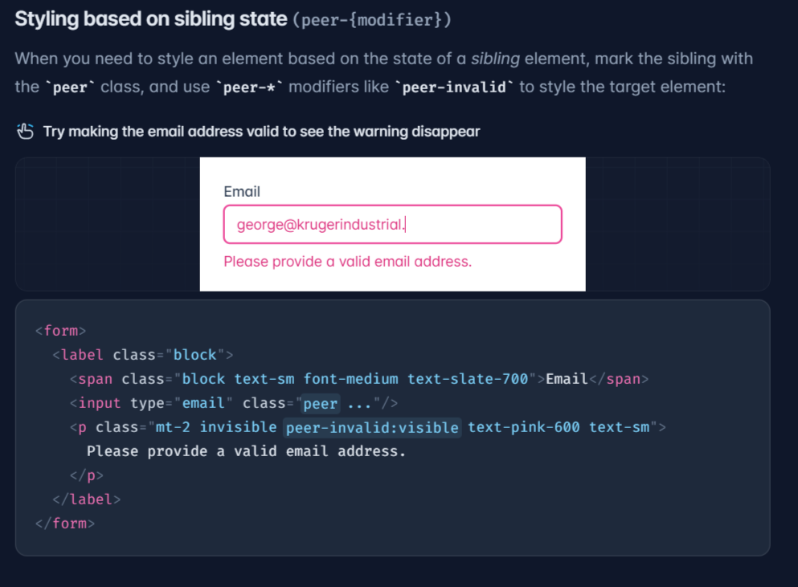

9.

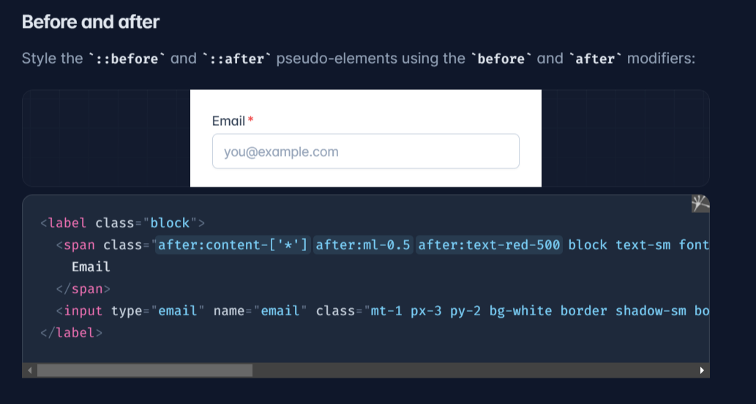

10.file

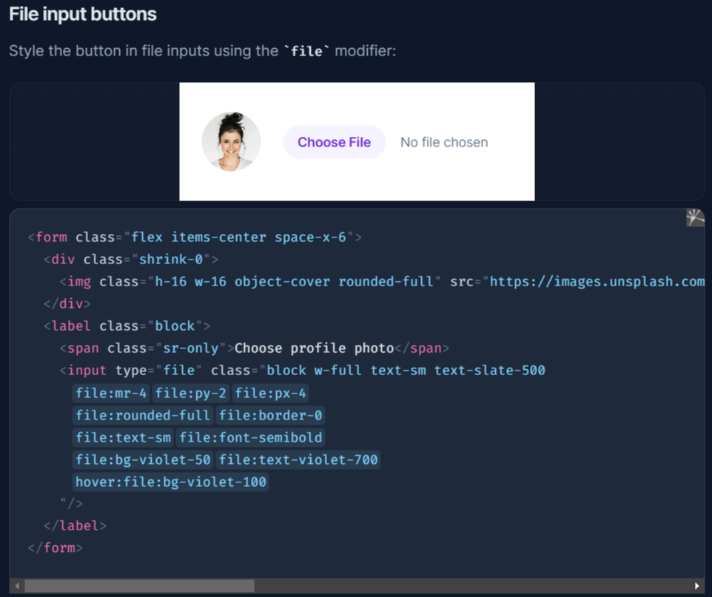

11.

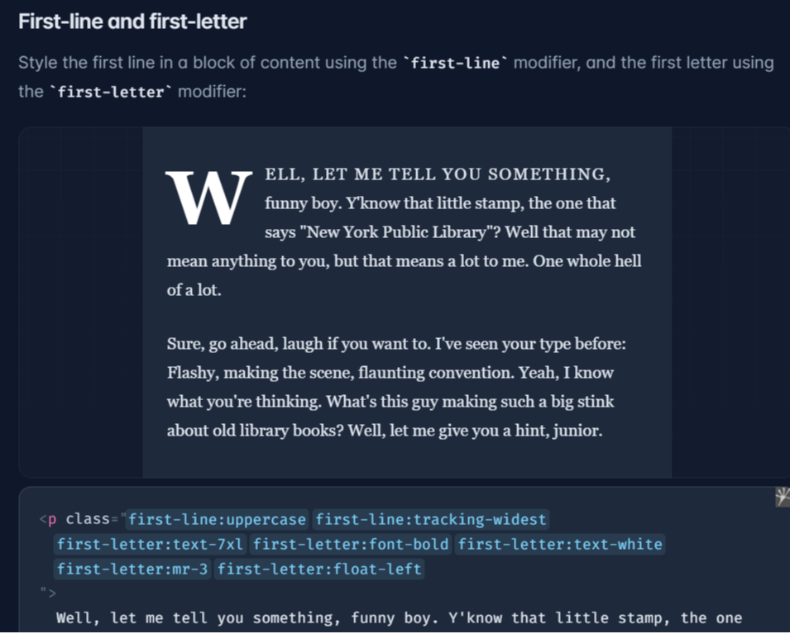

12.dark

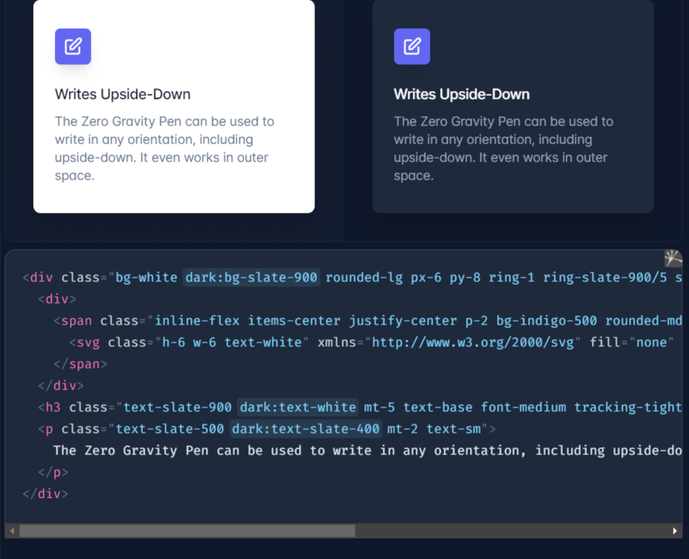

13. ::scrollbar and ::scrollbar-thumb and ::scrollbar-track

14. :placeholder-shown 🡪it works when we enter anything in input

15. :not(:pseudo-selector) 🡪 it will going to apply when not property

13. Directives

i)base directives :

@tailwind *base*;

Through this :we style the html component like : heading h1 and paragraph p and may more .

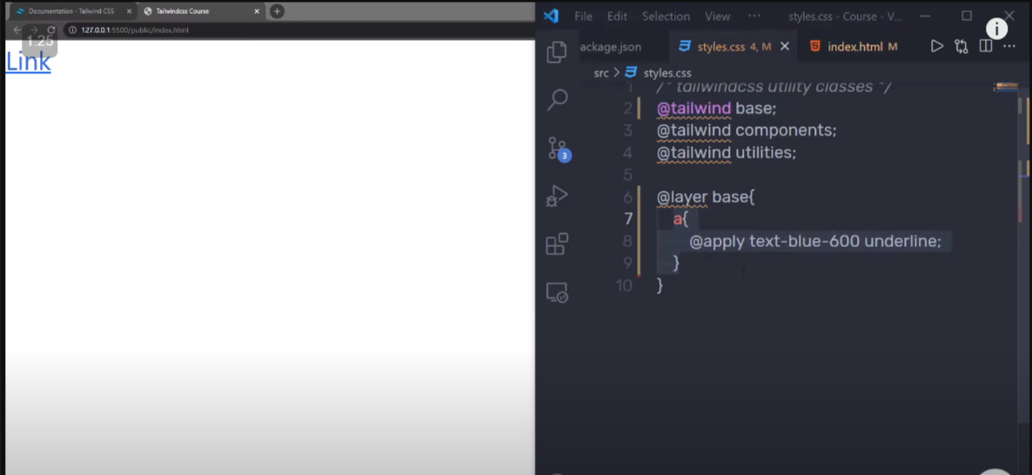

By using @layer base{} : I can change the default parameter for html component .

@layer *base*{

    h1{

        @apply text-lg font-bold;

    }

}

ii)component directives :

@tailwind *components*;

by using component we can create our own class

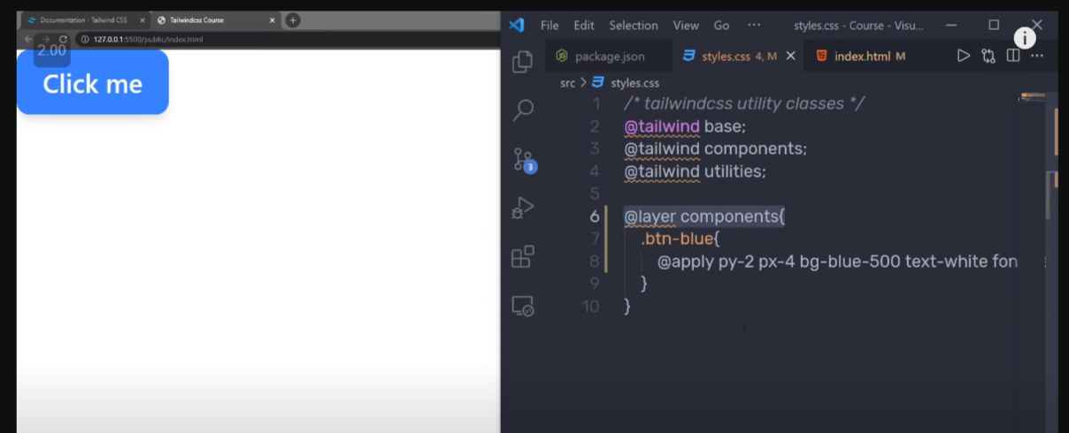

@layer *components* {

  .btn-focus {

    @apply border-yellow-500 border-2 focus:border-none focus:outline focus:outline-2 focus:outline-red-600

    focus-within:border-2 focus-within:border-black;

  }

}

1. Utilities directive we can change or add our new directives :

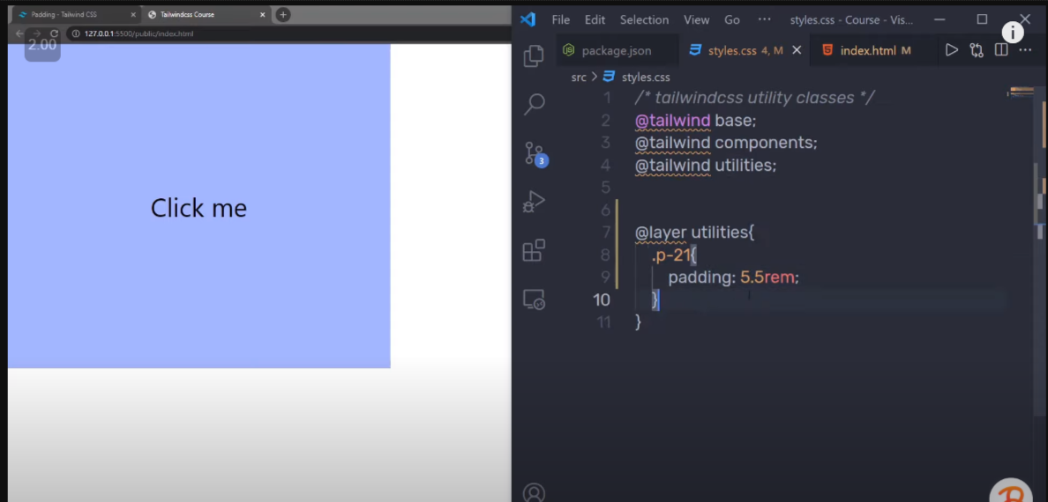

Note : in the above example I adding another utlites class for padding

iv)How @apply directive works ;

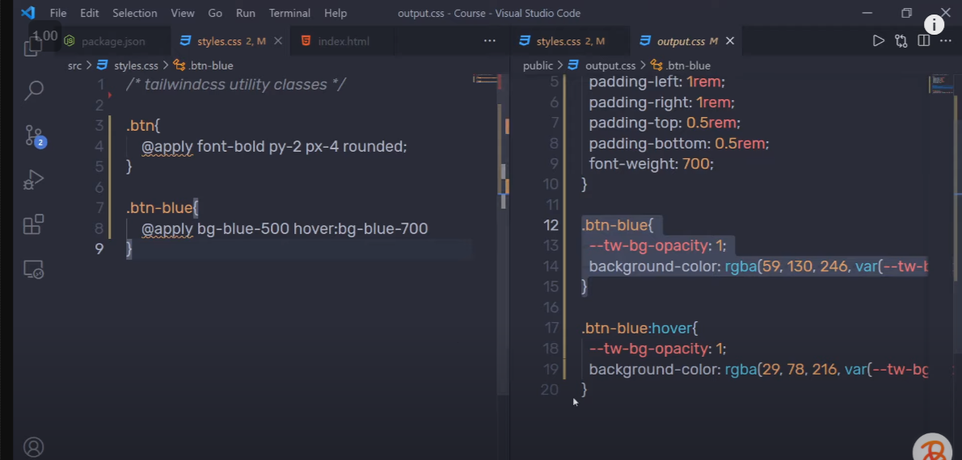

v) how @layer directive work

when I am using @layer then it will going to put everything I am in the particular directive

eg : @layer *base*{

    h1{

        @apply text-lg font-bold;

    }

}

In the above eg : h1 will be going to be put into the base directive .

vi) @varient directive

🡪using @varient directive we can specify the our own :

Hover ,focus , responsive or many other pseudo selector

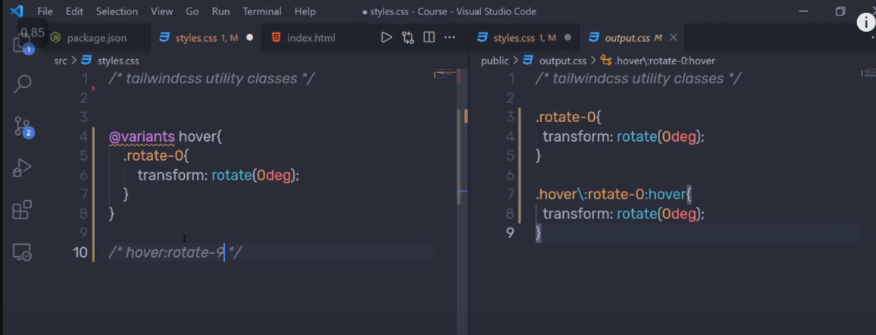

vii) if I want to create a responsive for any particular

I can use responsive directive : @responsive

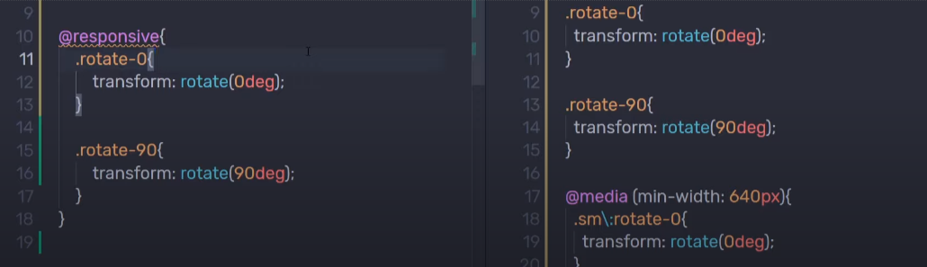

viii) @media screen(){} directives:

using @media screen() {} we can create our a responsive class for that screen only

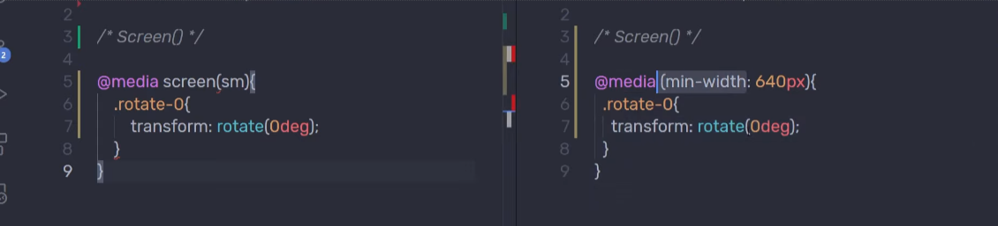

14.Postcss

🡪to install post css plugin we can use command to run in terminal

We need instal three module i)postcss ii)autoprefixer iii)postcss-cli

Command : npm I postcss autoprefixer postcss-cli

🡪After that run : npx tailwind init -p

It will going to create two file:

i)tailwind.config.js [if this file is present then it will not going to create a new one]

ii)post.config.js

🡪To complie our file with postcss we need to change the build that we have created during beginning :

“build”:”postcss sr/main.css -o public/style.css -w”;

{

*"name"*: "tailwind-css",

*"version"*: "1.0.0",

*"description"*: "Learnining tailwindcss",

*"main"*: "index.js",

*"scripts"*: {

*"build"*: "postcss src/main.css -o public/style.css -w"

  },

*"author"*: "Ajaj Alam",

*"license"*: "ISC",

*"dependencies"*: {

*"autoprefixer"*: "^10.4.8",

*"postcss"*: "^8.4.16",

*"postcss-cli"*: "^10.0.0",

*"tailwindcss"*: "^3.1.8"

  }

}

In main.css:(input file for postcss)

.btn::placeholder{

    @apply bg-green-600;

}

In style.css:(output file for postcss)

.btn::-moz-placeholder {

    --tw-bg-opacity: 1;

*background-color*: rgb(22 163 74 / var(--tw-bg-opacity))

}

.btn::placeholder {

    --tw-bg-opacity: 1;

*background-color*: rgb(22 163 74 / var(--tw-bg-opacity))

}

Note : above transformation is done with the help of autoprefixer .

autoprefixer: {},

15.JIT(just in time compiler): we should not need to specify all the tailwind css in our output (style.css) as we add class it will automatically going to add that class in style.css

🡪to enable jit we need to add mode in tailwind.config.css file :

/** *@type* {import('tailwindcss').Config} */

*module*.*exports* = {

  mode:"jit",

  content: [

    "./public/*.html"

  ],

  theme: {

    extend: {},

  },

  plugins: [],

}

🡪 then run command : npm run build

🡪we should also need to have :

i)postcss-cli (we install during postcss)

ii)tailwindcss (that we instal at the begning )

to compli jit

🡺 if I used some utilty class and then after using I delete that then to remove that I need to run command :

Npm run build

🡪If I want to give my own value of to utility class we can do that:

Eg : if I want to give height : 50px ; I can give that like this

Class=”h-[50px]”

text-[25px]

🡪we can also add !important : for doing that we just need to add ! just after of which we want to add.

Eg :

Class=”bg-green-500!”

16. Theme of tailwind.congif.js : using this we can change the default value of utility classes or create our own utility classes.

Eg:

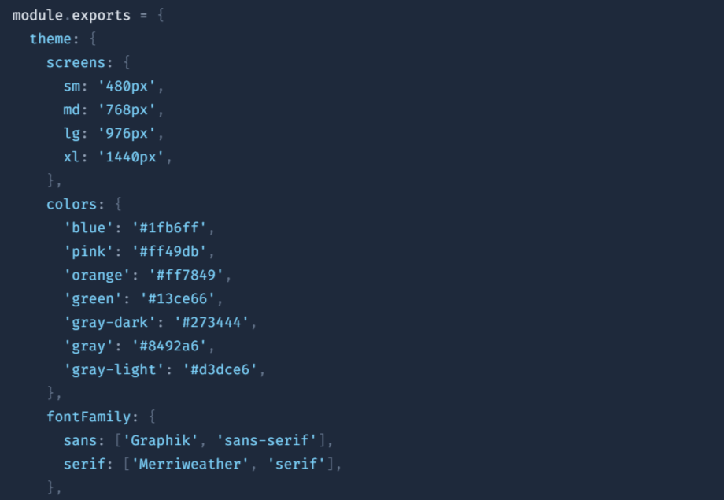

Note : during giving name and value : we can give name with/without the quote and for value we should need to use quote .

ii) under theme we have extend: through this we can create our own class

eg:

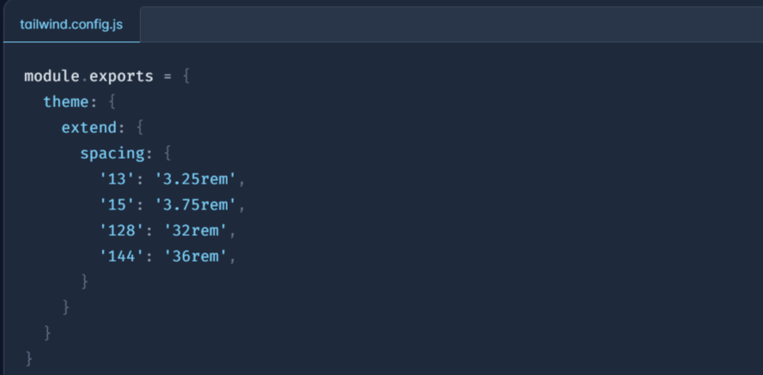

17.plugins of tailwind.config.js

Step 1: add the give at the top of the file



Step 2:

/** *@type* {import('tailwindcss').Config} */

*const* plugin = require('tailwindcss/plugin');

*module*.*exports* = {

  mode: "jit",

  content: ["./public/**/*.{html,js}"],

  theme: {

    extend: {},

  },

  plugins: [

    plugin(*function*({*addUtilities*}){ // here we are doing destructuring

*const* newplugins={

        '.scale-1':{

          transform:'scale(1)'

        }

      }

      addUtilities(newplugins)

    })

  ],

};

Note : we can add more than one property in newplugin object;

ii) do not to forget add ‘.’ Because we are creating class

🡺To create plugins with the responsive and with the pseudo element

plugins: [

    plugin(*function*({*addUtilities*}){

*const* newplugins={

        '.scale-1':{

          transform:'scale(1)'

        }

      }

      addUtilities(newplugins,{ 🡨

        variants:['responsive','hover']

      })

    })

  ],

18.dark mode

Step : to enable dark mode add the give in tailwind.config.js

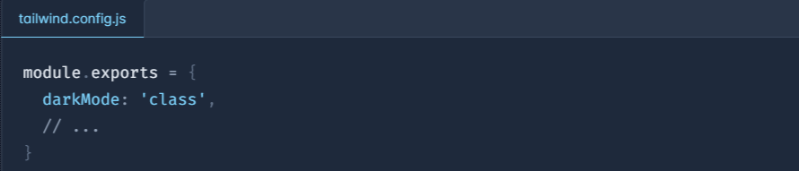

Step 2: write your code of dark with :=> class=”dark:bg-grey”

Step 3: To enable dark mode in our html file:

Add class=”dark” in our html tag;

